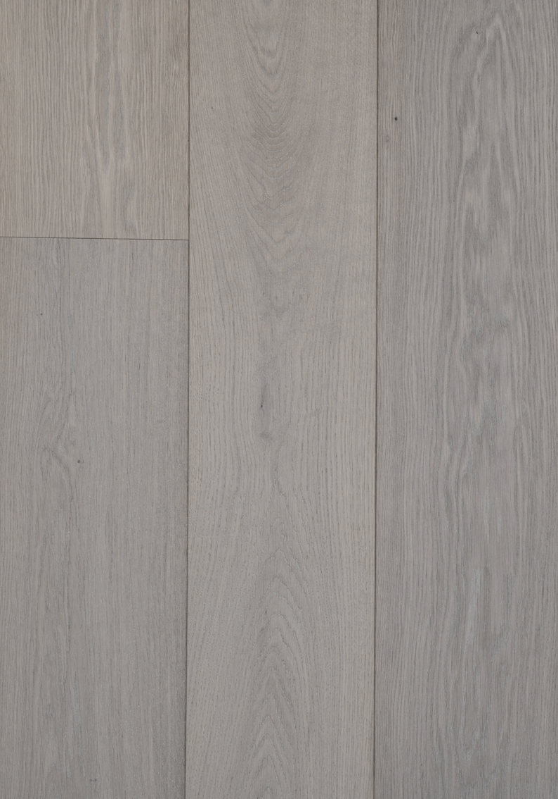

**INFO SHEET**

European oak ‘AURA’



INFO SHEET

European oak ‘AURA’

1. GENERAL PRODUCT INFORMATION

**SURFACE TEXTURE** medium brushed

**FINISH TYPE** stained, oiled & hardwaxed ultra mat

**COLOUR INFO\*** colour variation:

Please note that wood grades with more characteristics

(such as knots, cracks, heart line) show more colour variation.

colour behavior: very little changes over time.

*\*Although we strive to portray wood structure and colour as realistically as possible in all our samples and images, a single sample or any image can never act as a representation of an entire floor: no rights can be derived. Wood is natural material: variation in grain and colour occurs. Floors may also change over time due to the influence (or lack) of UV light, wear & tear, and maintenance.*

**CONSTRUCTION** 16 → 4 mm oak + 12 mm birch plywood

21 → 6 mm oak + 15 mm birch plywood

24 → 6 mm oak + 18 mm birch plywood

**AVAILABILITY**

**PREMIUM MULTIPLANK**

*\* Rift & Quarter sawn (vertical grain only)*

**AVAILABILITY**

**PREMIUM MULTIPLANK**

XXL

**GRADES**

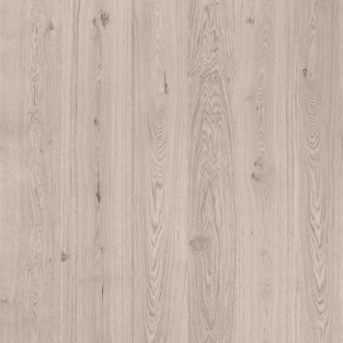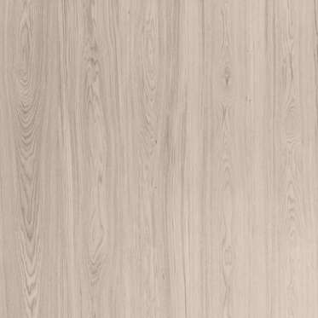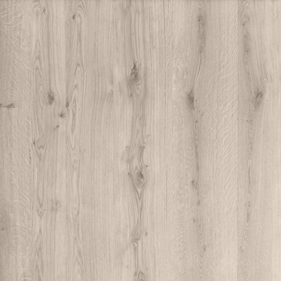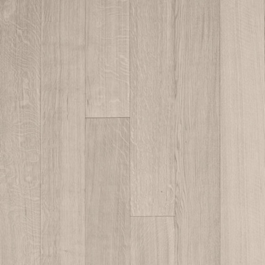

Rift & Quarter (R&Q) Select Natural Character

**100 – 220 mm**

|  |  |
| --- | --- |
| Rift & Quarter sawn | sound pin knots up to 1 cm, straight grain only, light colour changes, mirror flakes occur. |
| Select | sound pin knots up to 1 cm, very light colour changes. |
| Natural | sound knots max. 3 cm, knotholes max. 1.5 cm, light colour changes. |
| Character | sound knots without restrictions, knotholes max. 4 cm, heartwood, occasional cracks with a length up to the width of the board, bark pockets up to 10 cm, medium colour variation. |

**260 – 380 mm**

|  |  |
| --- | --- |
| Select | sound pin knots up to 1.5 cm, very light colour changes. |
| Natural | sound knots max. 4 cm, knotholes max. 2 cm, light colour changes. |
| Character | sound knots without restrictions, knotholes max. 4 cm, heartwood, occasional cracks with a length up to the width of the board, bark pockets up to 10 cm, medium colour variation. |

**BEVELS** micro bevels on the long sides only

**OPTIONS** long lengths only

fixed lengths

customized bevels

hardwaxed satin mat

Varnax – innovative, mat anti-scratch hybrid coating

misc. patterns (see next page)

complementary products (cladding for walls and ceiling, stair elements,

window sills, etc)

1. PATTERNS

**MIXED WIDTH** choose 2, 3 or even 4 widths and install these in a repeated system

**RANDOM WIDTH** choose 2, 3 or even 4 widths and install these in a random pattern

**HERRINGBONE**



*other dimensions on request*

**CHEVRON**

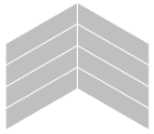

45°

60°

*other dimensions on request*

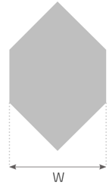**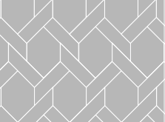MANSION WEAVE**

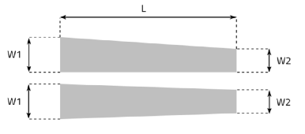**(SEMI) TRAPEZIUM**

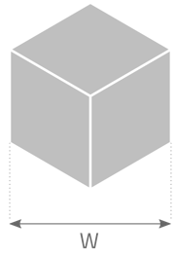**CUBE**

**QUADRO**

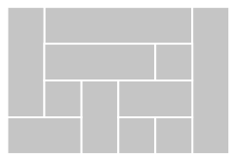

**CREATIVE**

1. SOCIAL AND ENVIRONMENTAL RESPONSIBILITIES

WOODlife’s owners genuinely believe their employer’s responsibility goes beyond just being good for your employees. Therefore, their production facility is granted an accredited social status, meaning that at least 50% of the employees has a certain degree of incapacity for work due to invalidity, disablement, deafness, personality disorders, and so on.

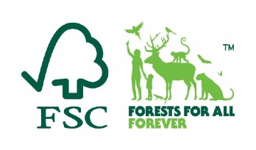

The European oak used is harvested from controlled European forests throughout Germany, the Baltic’s and the Ukraine, largely from FSC®- certified forests. Our certificate can be downloaded from our website.



Our products are finished using low-emission natural oils, hardwax oils and

water-based lacquers produced by Saicos Colour, Germany.

WOODlife’s multiplanks have an Excellent rating according to BREAAM. The approval implies that the products have passed tests for all major European regulations on the presence of VOC’s and Formaldehyde in wooden flooring.

Our flooring does not contain any solvents, isocyanides, formaldehyde,

Creosote, Arsenic or Chrome.

We do not waste any wood. Leftovers are used to produce skirting and home decorations. The remainder, as well as all our saw dust, is used as fuel wood to heat the entire factory including drying kilns. This reduces our carbon footprint substantially.

4 INSTALLATION & MAINTENANCE

**INSTALLATION**

* + We recommend taking app 7-8% saw waste for regular flooring and 12-14% for pattern flooring into account when calculating the amount needed.
  + Storage in the room at least 48 hours before installation. Packs are to be kept closed.
  + During installation, humidity should be between 35% and 70%, temperature between 18 ° to 24 ° Celsius.
  + Installation method: glue down or screw down is recommended, floating installation is possible in most cases.
  + Always take local installation standards into account.
  + Boards up to max 300 mm wide are suitable for under floor heating.
  + All oiled WOODlife floors are finished with natural oils and waxes and have been fully cured at the factory. Unlike oxidative oiled floors, our floors are fully hardened upon arrival and can therefore be used in any space, without any restrictions.

Also see the following documentation:

*WOODlife Flooring – installation guidelines.*

*WOODlife Flooring – underfloor heating.*

**CARE & MAINTENANCE**

* After installation, relative humidity levels in the rooms should always be kept between 30% and 70%.
* Please be aware to place humidifiers/vaporizers during the wintertime if needed.
* Ventilate the spaces on a regular basis.
* Our floors require regular maintenance; frequency strongly depends on type of use. A rough guideline:

|  |  |  |
| --- | --- | --- |
| Daily cleaning: |  | Dry cleaning |
| Periodic cleaning: |  | Saicos Wash Care (parquet friendly soap for mopping) |
| Maintenance at regular use: |  | Saicos Wax Care (maintenance oil), 1 or 2 times per year |
| Maintenance at intensive & commercial use: |  | Saicos Wax Care (maintenance oil), 3 or 4 times per year |

Also see the following documentation:

*WOODlife Flooring – maintenance guide.*

Afbeeldingsresultaat voor copyright signCopyright 2021 by WOODlife Flooring BV.

All rights reserved.